MINIO LEAST PRIVILEGE ACCESS CONTROL LAB

- Create user
Give access of user to one bucket

Create a training user who can access only student data

Create a training user
Username – student01
Password – Student@12345

- Create a least privileged policy
Don’t want to student1 become admin
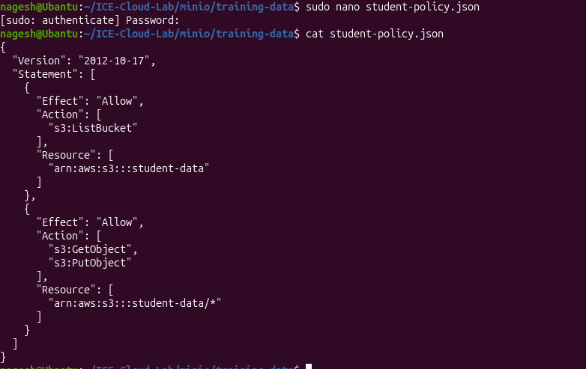

- Add policy to student

- Attach the policy to the student

Now user student01 have access of student-data of only read and write

Test the student account

Now check
You may notice that student can’t necessarily list all buckets only access student-data

- Test Upload permission

Upload it

- Lab : - Object Versioning

1.Enable Versioning
Verify

- Create Version 1
Create a test file
- Upload it
Run this command of not working upload file through browser
Verify
You should see
Version-test.txt

- Modify the file
Now create version 2
- Upload it again
Run this command of not working upload file through browser
Minio should maintain both version
- View the versions
You will see
Version-test.txt
You will notice diff version ids
Demonstrate accidental deletion
- Now delete the version
Verify
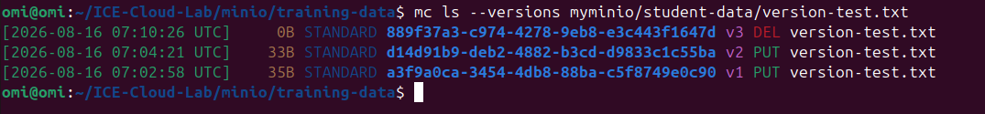

- Restore the previous version
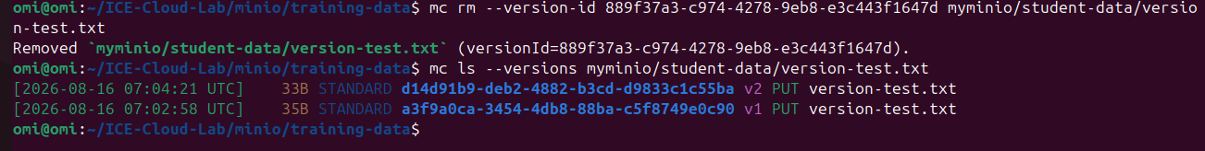
- If permanently delete a version 2
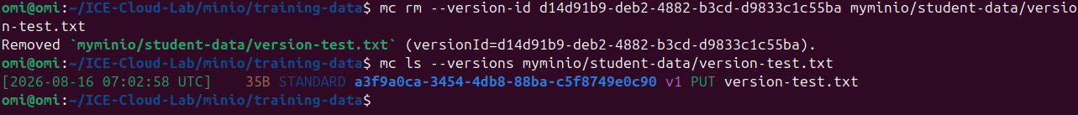

ACCESS KEY
Access key authenticate applications and users to cloud storage
- Create an application user
- Create an application Policy
Create the policy file
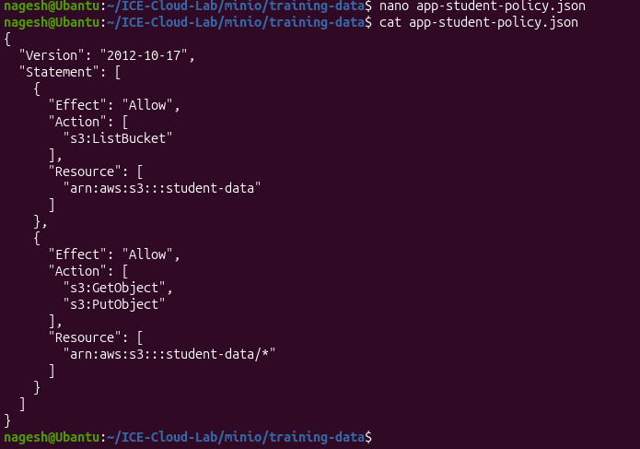
- Create the policy in Minio

- Attach the policy
Now the application account has only
List-Read-Write
It does not have user administration, bucket administration, access to finance data, access to employee data, server administration
- Generate Access Key
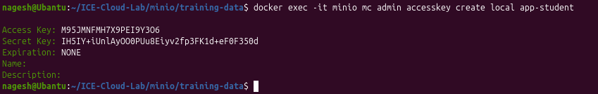
- Configure the application alias
Copy your access key and secret key
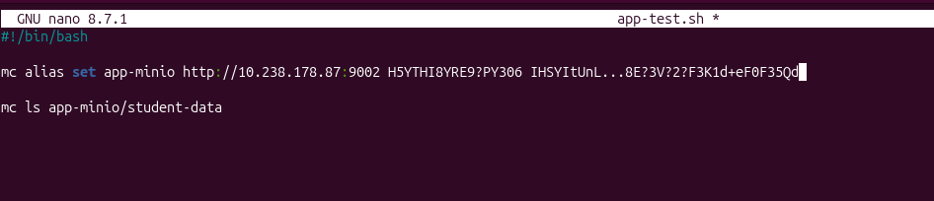

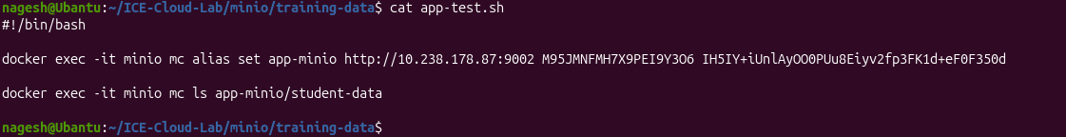
- Make It executable

- Run
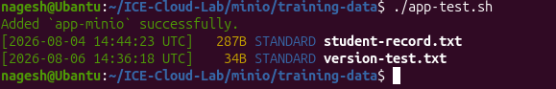

- Test Reading Data
